Guidelines for Individual Experiment Reports
Title: What is the name of your experiment?
Purpose: What do you want to find out?
Hypothesis: Why do you think that will happen?
Materials: What materials and equipment do you need?
Method: What are the steps you are going to follow?
Observations: Clearly Describe your Observations. Make a results table if needed
Analysis: What have I found out from your observations and data collection?
Conclusion: Explain IF your Hypothesis was correct.
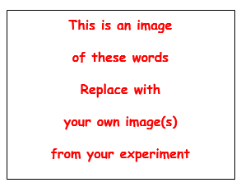Include a title for your picture

DIRECTIONS ~ FOLLOW THESE DRECTIONS CAREFULLY !!!

- Delete all the word in red before you print this document.
- Your NAME ~CLASS ~ DATE Must be included at the bottom of the page.
- You may use any font, size and line spacing that you want... But Remember...
- All the Items in Black must be included and fit on one side of a piece of A4 paper
- You must include at least one photo of your individual experiment.
Note: you may include more photos on another sheet of paper.
- All photos or tables or graphs should have lables
- Use your design skills to make the page look good.

NOTE: IF, you turn in your Individual Expriments at least 1 week before they are due
THEN, they will be graded in time for you to correct and resubmit them for a higher grade.

INCLUDE YOUR
NAME: ...................................... CLASS: ........................... DATE: ................
At the Bottom of the page

